**#1.1 - The Sword Tree**

Monday, January 19, 2015

3:18 PM

**\*\*\*\*\*\*\*\*\*\*\*\*\*\*\***

**1.1.1 Overview**

**\*\*\*\*\*\*\*\*\*\*\*\*\*\*\***

Elsword, a mysterious giant tree shaped like a sword that bears a fruit that heals and replenish life. It is also known as the main food source of the people of Aviv.

The tree is like a tower. It's has many room like in a mansion of a rich noble inside. And each room have the fruit in it, it glows and floats magically at the center.

The people of Aviv are not like people of the outside world, they look healthy (not fat, not thin) and young, this because of the fruit. They live peacefully in harmony. But now, not anymore

Before they are permitted to enter and pick the fruits freely. But the tree has been taken over by a man who wants to do business.

Suited in armor, he was the leader of the Guards who attacked Rolan inside the tree and the father of a pretty young girl, lawthan. He owns a mysterious magical machines.

He uses that weapon to stop people from getting the fruit. But wants everone to pay him moneyand riches for the tree.

**\*\*\*\*\*\*\*\*\*\*\*\*\*\*\*\*\*\***

**1.1.2 Key Ideas**

**\*\*\*\*\*\*\*\*\*\*\*\*\*\*\*\*\*\***

1. (Rewards) Grants you a divine defense pendant that gives 70% evasion.
2. (Game idea) A battle
3. (Game idea) Time limit mission.
4. (Game idea) Stealth
5. (Game idea) A side scrolling mini game (Collect the Super Fruit inside the dungeon.)
6. (Setting) A giant tree with an interior similar to a mansion. This is a special dungeon.
7. (Characters) Monster Machines runned by a mysterious power related to the power of the obelisk.

**\*\*\*\*\*\*\*\*\*\*\*\*\*\*\*\*\***

**1.1.3 Music Idea**

**\*\*\*\*\*\*\*\*\*\*\*\*\*\*\*\*\***

1. <https://www.youtube.com/watch?v=UQkxNbgohPg>

**\*\*\*\*\*\*\*\*\*\*\*\*\*\*\***

**1.1.4 Visual Idea**

**\*\*\*\*\*\*\*\*\*\*\*\*\*\*\***

**\*\*\*\*\*\*\*\*\*\*\*\*\*\*\***

**1.1.5 Flow Chart**

**\*\*\*\*\*\*\*\*\*\*\*\*\*\*\***

***\*Exploration\****

Rolan first enter to a path that leads to a cave, he noticed it was entirely guarded. Upon entering it there is another open path that will skip this area. If Rolan approaches the Guards it will trigger an event. Guards will start to act and attack you as the place is forbidden.

***2 possible game: Stealth***

***\*Side Quest - Get thru the dungeon path - A\****

If Rolan went outside successfully. It will show a special event.

The guards will report to their leader what happened, but the leader just ignore it because he is busy having lunch with her daughter, saying that they are having an important discussion.

***\*Side Quest - Get thru the dungeon path - B\****

If Rolan failed, it will show a special event.

He will be taken inside the prison cell, he will see beside a glowing fruit, and if he ate it, it will recover his life. Rolan must get away inside the cell. If Rolan managed to escape, he will see a secret room where a Giant Mechanical Armor is standing. After that, Rolan will return halfway to the exit of the dungeon.

After getting outside, he will a boy walking near the tree and when he got close, the Guards saw him and kicked him. And when the Guard tries to get the boy to throw away, Rolan acts to stop the Guard, initiating a battle scene.

After the battle, the guards will report to their leader what happened, but the leader just ignore it because he is busy having lunch with her daughter, saying that they are having an important discussion.

***\*Exploration\****

Meanwhile, Rolan enters the village, he met a working man beside a house. That man talks about making a fun game getting fruits from that tree. He also said, that he interested of selling those fruits to other countries… but his Son don't like that idea."

Rolan next goes to the room where the boy is. The lady told them that the Guards knock down the kid. One of the villagers advised the working man to stop doing nonsense and start taking care of his son.

Next, Rolan enters the mansion, he saw a Girl playing her doll. When Rolan talks to her, she will say good things about her father, why her father did take over the tree is because he care for people, and he wants to prevent war. Then a maid comes. "Ma'am the ride is ready. You're is waiting."

"Oh, I have to go. Sorry."

She went down leaving Rolan.

***\*Exploration\****

Rolan is back exploring the place again. But if he returned to the village, and check the house of the boy, he will encounter an event.

***\*Side Story\****

The Girl visits her friends. They were her friends already for 2 years after the take over of the Tree.

Her friends, including the boy, are hiding the truth to her, because they don't want to hurt her feelings. But the truth they hated her father.

Eventually, she learned how they feel also knowing the boy's injuries and other people. And so she decided to talk to her father to solve the problem.

*"I know, it's for people why he wants to do this, he just helping them to prevent war. He should know what they feel. I believe he will understand."*

After that, she went to her father, and report the issue, she request to let the tree be free.

But unfortunately, her father reacted negatively.

She was shocked hearing her father talk such things, it's not like him. "You're mother!! Is a garbage! You don't know!? She is an ungrateful piece of a garbage!"

He called the Guards and commands to throw the girl away.

The girl, faced the Guards and thinking that the Guards will help her "Please, there's something wrong with my father, please help him!" And they captured her. "Help my father please!!" "This is not happening!"

He revealed that her mother is ungrateful that's why he throw her mother away.

*"Being fair, makes people happy, that is why I'm stopping people to fight."*

Eventually, the daughter will be thrown away. And no one knows what happened, what the boy and others know is she is not returning. The evil man, still continues the work and people are now angry.

***\*Exploration\****

Rolan is now free to spending time exploring the village, talking to children, an event will trigger if Rolan returned to that tree. There he will confront the leader.

"You did come inside this property of mine. You should be dead already if I didn't do anything. So I'm giving you a chance to live, leave this place a once."

But Rolan still continue going forward towards him.

Leader: "Pity..."

Leader: "How ungrateful."

***\*Side Quest - Defeat the Leader!\****

On the first trial the man gives his best attacks.

***\*Side Quest - Defeat the War Machines within time limit!\****

After the battle, he will order to release all the weapons, they are not just one, but more, revealed as war machine-robots runned by a magical source, to attack the villagers. Rolan must stop all of them before the time runs out.

Rolan can battle the Robot but the possibility of defeating is not possible as it is like (Rolan's level is 7 and their level is 30) (except if rolan's level is very high). The most suggest is the field puzzle solving in order for them to be destroyed.

After the fights, Rolan will fight again the leader, but now, the leader is not anymore in good shape, (not worth saying as side Quest anymore, as it is fixed that he will be defeated anyway.) After this, there will be a cut scene.

***\*Side Story\****

Rolan ask him to change, and "let the people share the Tree. Stop making them pay, and instead protect the tree. It will make them really happy." But the leader, refused. "How dare you lecture me!" And there he rush attacked Rolan reclessly but missed, ('No!' Rolan didn't expect him to fall) he lost his balance and fall down the cliff or brocken robot crashed to him.

***\*Side Story - Ending, Bonus item and a Mini Game\****

Aftermath, they saw the girl back, holding her glowing pendant. She didn't know what happened at all she knew is that she is thrown away by her father.

It will reveal that pendant have some kind of magical stone that made her survive. It will also reveal that her mother discorvered it when she was young, and then gave it "simply" to her father because of love. *Her mother don't know yet that her father have problems."

Then mini game will appear hosted by the here, I am not sure yet what it is but it’s like a mini game platformer inside the tree with a goal getting fruits to score with a time limit. "The boy told me to move on and forget the bad things happened."

Later her father killed her mother (She didn't know anything about it), because of thinking that her mother is a leech and ungrateful after all he have done. He, her father, don't need someone who is a burden, and that he killed her mother. (but the truth is, her father is ignorant.)

Her father is very kind but the problem is he always is always expect something in return. So if he give something to you or help you, expect that if he also need something from you, you must also provide or else you're dead.

**\*\*\*\*\*\*\*\*\*\*\*\*\*\*\*\*\*\***

**1.1.6 Demo**

**\*\*\*\*\*\*\*\*\*\*\*\*\*\*\*\*\*\***

The demo is similar to how old rpg game use Stealth.

**\*\*\*\*\*\*\*\*\*\*\*\*\*\*\*\*\*\***

**1.1.7 Q and A**

**\*\*\*\*\*\*\*\*\*\*\*\*\*\*\*\*\*\***

1. What's the point of the Pendant?

This is simply showing the character's personality in the story. Without it you can't completely say her mother is generous and kind, because you're out of proof.

As the story says, her mother gave her 'precious' pendant to her father as a meaning of love. This simply displays how grateful she is having a lovely and generous man. This also strengthen the negative character of the villian, as he even ignore the generosity of his wife.

1. Is there a back story about the tree? Why the tree is called sword tree and why it is shaped as sword?

The sword is only a symbol and the tree is the meaning, giving that the weapon of life is sharing.

The Backstory can be like this:

*Hundred years before, there is an ruined mansion guarded by a boy. The Ruined Mansion's roof has a hole on it where the light passes thru. That light passes thru lits a space where small plants are placed. It is guarded by a Boy. Eventually, the mansion is planned to be destroyed. And when the boy learned about it, the boy asked for help to the neighbors to stop the authority to do it. This will reveal that the boy is the son of the mansion's owner. Later, the boy received from his step parents that it will not be destroyed, so he believed in it but later it will revealed as a joke. So on the day when the mansion is planned to be destroyed… the boy is inside it, planning to plant more as he is putting many seeds. The mansion is destroyed including the boy.*

*Hundred years later, one of the seeds grows, and mysteriously shaped like a sword, it seems that the tree magically inherits the mansion's interior design.*

1. Purpose of the tree?

The purpose of the Giant tree is to make a unique secret dungeon that inspires the idea of sword tree.

#2.1 - Mina's Rant

Monday, January 19, 2015

5:06 PM

**\*\*\*\*\*\*\*\*\*\*\*\*\*\*\*\*\*\***

**2.1.1 Overview**

**\*\*\*\*\*\*\*\*\*\*\*\*\*\*\*\*\*\***

Mina - Is a 14 year olf eastern country girl who loves to explore many things and didn't like school. She loves books and reading, and have knowledge about the lost language of the ancient world. She have a high interest in history. Because of her knowledge and intellect, she dislikes going to school, instead, studying and taking notes about nature outside. Mina's inspiration is Success and gives credit to knowledge and intelligence.

Rolan meets her as a stubborn kid who dislike school. Rolan wants to stop her because of her parents, who are working hard for her going to school.

When she went finally outside to take on an adventure, but end up in a mysterious cave where a Giant Serpent is sleeping, you will learn that she can really deal the challenge in real life. I'm not saying that all child can do what she can do, she is just capable of doing it as her character origin is refers knowledge and intelligence, now her act shows of it's application.

**\*\*\*\*\*\*\*\*\*\*\*\*\*\*\*\*\*\***

**2.1.2 Key Ideas**

**\*\*\*\*\*\*\*\*\*\*\*\*\*\*\*\*\*\***

1. (Reward) Accomplishing this side quest will grant you a recovery equipment and future secret merchant.
2. (Game) Boss Battle
3. (Setting) I'm thinking of non existing area in rolan's Quest that shows healthy environment. This lead me to the idea of a mysterious room that shows the "should be" future of the world. The Dream is only a reason as this kind of place is non-existent.
4. (Concept Design: Monster) A Snake traped in a Cave, turning out, that the cave is it's body or armor.

**\*\*\*\*\*\*\*\*\*\*\*\*\*\*\*\*\*\***

**2.1.3 Music Idea**

**\*\*\*\*\*\*\*\*\*\*\*\*\*\*\*\*\*\***

**\*\*\*\*\*\*\*\*\*\*\*\*\*\*\*\*\*\***

**2.1.4 Visual Idea**

**\*\*\*\*\*\*\*\*\*\*\*\*\*\*\*\*\*\***

**\*\*\*\*\*\*\*\*\*\*\*\*\*\*\*\*\*\***

**2.1.5 Flow Chart**

**\*\*\*\*\*\*\*\*\*\*\*\*\*\*\*\*\*\***

***\*Exploration\****

Rolan saw a cave and enters it. There he saw an unusual head of a giant snake that seems to be sleeping, it's name is unknown, but learning it will tell you, it's name is Jormurgand. If you tried to talk on it, it will not respond so there's nothing to do here.

Rolan enters a village, where he saw a girl running. If he speak to her… the girl will say,

"Why should I go to school if I can just read from books what the teacher is telling us?"

"It make no sense, right? I rather go have fun outside." and then she runs away.

You will hear, after that, a dialogue, coming from her school, saying "Miko? Present. Alena? Present! Mina?... Mina?? Absent!!... Absent again? Oh where did that girl go this time."

If Rolan enters a house where there's a woman cooking yet worried on something. If Rolan talks to the woman, the woman will say, "I hope my Mina got Good grades."

If Rolan also encounters her husband outside cutting wood, the husband will say, "It's hard these days, rice is getting more expensive."

If you ignore these events, you will not be able to trigger a special event that follows. If you didn't… and go outside, you will see the Girl walking away.

***\*Mini Game - Follow her and avoid being seen\****

What will happen when Rolan goes outside is he will see Mina, running with her bag pack. You must follow her and avoid being seen. When you reached her in the middle of the road, the rain will fall, and she will run to a cave.

***\*Side Story - Part 1\****

This will trigger an event about her. Her story is that she hates her parents because of making her going to school. And so she leaves. Now she is waiting for the rain to subside.

After that she falls a sleep…

A flashback triggers (A desaturated sprite event), you will see her facing his mother and father having a talk, (here you will understand that her decision to go away is great, because what you will witness is a scene of her father and mother talking about money. She thinks that all they want is money thinking that she will be like a Cash cow to them after she finished schooling. And there she goes away.

When Rolan, follows, he noticed Mina is gone. He looked left and right and then scratches his head.

Mina mysteriously disappeared.

***\*Exploration\****

Rolan again is free to explore. Now if he returns to the village and went back to the Mina's house, he will see that the she is there. (what happened how she got there is a mystery. It even ignores the logic of time.)

***\*Side Story - Part 2\****

Mine with her parents staring at the top of the table full of amazing fruits and vegetables. "How on earth you get all of these." Mina laughed and smiled. Both of them looked at her and got confused. "Why not enjoy the food?" Mina said *she eat also the fruit* I got it from a friend."

Mina told them… (Flashback)

Inside the cave near the entrance, she is sleeping. After the rain subside. She went up, her face looks like still wanting to have more sleep. But she became shock of what she saw. She saw something weird and went outside.

"What is going on here?" she said.

She saw bright sky, vibrant trees and rivers. She saw fruits and vegetables and healthy plants. The place before is not anymore like it, it's different and beautiful.

It's like a paradise.

Eventually, she is throwing her stuff out her bag. And then runs away back to her home with her bag full. "Mother! Father!"

"I don't know what happened, but it seems that I sit on something magical."

"It transforms the place outside to a some kind of a paradise."

*(This lines is important. As it gives you clearer hint how you will get inside this mysterious place. If you missed this, you can still explore getting the it.)*

After this, they stop, and the she looked at Rolan, "Hey! Why are staring at?" Then she pushed Rolan and closed the door. After a few seconds. You will see them going out at the back of the house.

***\*Exploration\****

Rolan is free again to explore, if he proceeds, he may go visit the cave.

***\*Side Story - Part 3\****

The head of the monster appeared facing them, angry. Her father acted immediately to saved her daughter and run away.

But the Girl shouted, "No!!! It's not evil!"

But unfortunately… it attacked, using it's Roar.

All of them fainted, including the Girl. Then Rolan saw the entrace of the cave shut. He have no choice but to find a way to get inside.

***\*Side Quest - Beat the monster and save the 3\****

When Rolan succesfully got inside, he will fight the monster. He must be cautious as the monster can deal heavy damage and area of effect attack. Rolan must not let it happen so the girl and her parents will not take damage. If Rolan or one of them die the quest will fail.

After the battle, the monster fainted. (Scene Fades)

***\*Side Story - Conclusion\****

After the day, the Girl went again outside, happily and lively to explore the world. Her parents looks like they give up on her but they wished on her safety.

***\*Aftermath\****

The end is only the beginning. Rolan can now have an access to an optional quest where he can explore more about the monster. Unlike before, he is now allowed to talk to the monster.

Here's is the important part. If you do this side quest, you will see a good ending to this, you again meet her at the end before final boss. You will see her at her house, she made her parents happy. Now she is selling rare items for you to buy.)

**\*\*\*\*\*\*\*\*\*\*\*\*\*\*\*\*\*\***

**2.1.6 Demo**

**\*\*\*\*\*\*\*\*\*\*\*\*\*\*\*\*\*\***

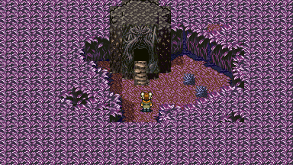

*Mina saw a Cave and entered it.*

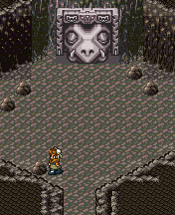

*BEFORE Mina saw the head of Jormurgand sleeping*

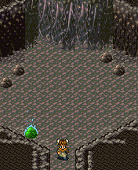

*After Notice that the head is gone but the stone where mina slept turns green.*

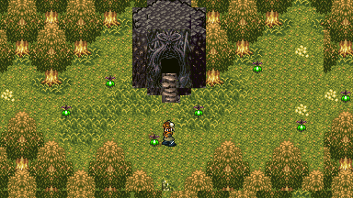

*When Mina went outside the cave she saw a beautiful place.*

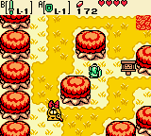

*The Tast maybe similar to Legend of Zelda Oracles of Season, when Link Follows Rosa. Think Rosa is Mina in this screenshot.*

Battling Jormurgand - In order to win the battle the monster's HP must turn to 0.

Conditions: Rolan must survive and also 3 characters. A lifebar with appear next to Rolan's HP panel, indicating the HP of the 3 characters. If one of the character dies, the quest will fail and you'll lose.

Jormurgands attacks are ranged and splash, and one of them deals poison. His ultimate attack is roar, that can deal heavy damage to all and can cause paralysis or immobilize to Rolan.

Chances of Winning:

One of the monster's range attacks can be reflected using your sword, the other can be evaded. The monster is highly predictable as you can read it's attacks on its delays. Rolan must be well equiped to win this battle to prevent status effects. Rolan can heal the other character's life. Rolan must be higher level and can deal great damage to this monster.

**\*\*\*\*\*\*\*\*\*\*\*\*\*\*\*\*\*\***

**1.1.7 Q and A**

**\*\*\*\*\*\*\*\*\*\*\*\*\*\*\*\*\*\***

1. The ending tells that parents are not good because they let their child go on her own ways, is this good or bad? I'm not telling how to raise a child here, and it is also unfortunate that her parent's didn't fight to stop her leaving. It's now up to Mina how she will tackle the challenge in life.

1. Is Mina gives a role of a bad child? She is subborn. But If she IS bad then she should be in jail or killing. She may seems ignorant about her parents effort, making you think she is a bad child, but, then why she returned with good things or gifts to surprice her parents? Why she returned again making her parents now stable in life, when she is now become a successful merchant? She maybe thinking about adventure, world and knowledge but her heart still never forgets where she came from.

1. What is the Snake? It's the ancient first creature of the world that lived billions of years ago, it is known as God before by the ancient civilization. Later, it was sealed by a powerful being named Caroline.

#3.1 - A Monster's Dream

Sunday, February 01, 2015

12:30 PM

**\*\*\*\*\*\*\*\*\*\*\*\*\*\*\*\*\*\***

**3.1.1 Overview**

**\*\*\*\*\*\*\*\*\*\*\*\*\*\*\*\*\*\***

This quest will lead you to discover the mystery behind the monster and the secret place, and by doing it, you will be rewarded. For now, the monster, Jormurgand, ask items from you, but our question is "Why?"

Information are scattered anywhere as if they are scientific evidences or anecdotes. This notes acts like pieces of puzzle that will lead you to reveal the real identity of the monster and the secret place. By learning and having these notes you will uncover the answer why the monster ask for items.

The items is the monster's dream basis to create the a Dreamworld.

**\*\*\*\*\*\*\*\*\*\*\*\*\*\*\*\*\*\***

**3.1.2 Key Ideas**

**\*\*\*\*\*\*\*\*\*\*\*\*\*\*\*\*\*\***

1. (Reward) Rare items that can be obtained inside a room but visually presented as part of a vast place.
2. (Game) Fetch quest and puzzle.
3. (Setting) A cave where there's a vibrant rock that acts as a key to change the setting outside of the cave into something else. That change is a room that looks like part of a vast place. Example: Just a portion of a desert, you cannot go further than what you see on the screen.
4. (Concept) A mysterious monster or Demigod or a symbolical ancient being linked to the power where the obelisk is originated. It's dream is a room that can be accessed by people who steps on a magic Rock.
5. (Concept) An empty room that can turned into a magical room if requirements are met. Grants the player bonus items inside it.

**\*\*\*\*\*\*\*\*\*\*\*\*\*\*\*\*\*\***

**3.1.3 Music Idea**

**\*\*\*\*\*\*\*\*\*\*\*\*\*\*\*\*\*\***

**\*\*\*\*\*\*\*\*\*\*\*\*\*\*\*\*\*\***

**3.1.4 Visual Idea**

**\*\*\*\*\*\*\*\*\*\*\*\*\*\*\*\*\*\***

**\*\*\*\*\*\*\*\*\*\*\*\*\*\*\*\*\*\***

**3.1.5 Flow Chart**

**\*\*\*\*\*\*\*\*\*\*\*\*\*\*\*\*\*\***

***\*Exploration\****

Rolan now is free to explore.

Rolan can visit the cave, but the monster doesn't make sense when it talks. Except that, when you talk to it, it will open an item box to give it an item.

You can leave it if you want and continue the main plot. But if you pursue this task, you will be able to unlock secrets.

***\*Side Quest - Recovering the Mysterious Place\****

The stone gives indication what is now happening in the cave. It's color indicates changes of the outside of the cave. If you check the stone, an option will appear, it will ask if you want to rest or not. If you rest and wake up, you will see changes outisde the cave. If you want to return back, just check the stone again, and choose rest. After the shift, go outside and you're back now to the real outside of the cave.

At first it will be an "empty place". Different to what the girl saw in the first place. The girl saw in the first place is like a "fully furnished" Dream place that looks like a greeny lively forest. But now, it looks like an empty desert.

That place she saw is *your Goal.*

If you understand what you are going to do, you will get this placed furnished by giving the monster anything.

To be specific, it will make the monster friendly and will allow you to obtain more rare items from that place. However, you cannot give him the same item again like you are going to give him potion then another potion again, you cannot, as it will not add into the account.

Each items have their own "Points", like if you give him potion it will add +1 points for improving the dream place, but if you give him another again, it will do nothing. Just fill him up with different items and you are going to get improvements of that Dream Room. And when you get there, you will obtain secret items inside. Remember to not give him rare items, as it will not add points and just put it to waste.

***\*Challenge\****

Now the problem is that, you will not know everything about it easily. If you don't pay attention to dialogues that comes from the story, artifacts like books, and NPCs, you won't get any clue. What you will get is only talking to a monster that gives dialogue that make no sense. So there should be some kind of equipment in order for you to understand what the monster is saying.

***\*Solutions\****

You have to travel and explore. Hints and clues will lead you to a revelation about that mysterious place. And here will tell you that the place is made from the dream of the monster.

Scattered artifacts that gives information: Mysterious old journals from maybe an ancient tribe or inside a cave or a mysterious room of a dead guy. Rolan collects these in a form of a memo.

**Examples:**

*Book 1: In ancient times, a monster called Wormwood is being thrown away by the Gods. It's been said that it dreams are turning real.*

*Book 2: Gods create worlds by their own imagination. Well, that is what scriptures says.*

*Broken Tablet of Magi: Astar, where we obtain the materials for creating it, is a planet of the highest. Living there are 'Gods' by the way, but they are just advanced civilization gifted with an unlocked power to create a world by imagination.*

*Broken Tablet of Magi 12: We are planning to do something that inspires that ability. A monster that can project a space using its mind.*

*From a possessed Magician: We have figure it out and we did it correctly, we successfully did copy what the highest can do. But unfortunately we failed...*

*Comes from a letter of a dead guy: The monster should obey us yet what we have is a lazy pig. So we just throw it away to the abyss.*

**Aftermath:**

After completing this side quest, you will be rewarded treasures inside the dream of the monster. Now if you want to get more, theres another and final quest you are going to do here. Check the *Nightmare of the Monster.*

**\*\*\*\*\*\*\*\*\*\*\*\*\*\*\*\*\*\***

**3.1.6 Demo**

**\*\*\*\*\*\*\*\*\*\*\*\*\*\*\*\*\*\***

2.2.4.1 - Draft

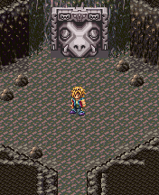

*When Rolan revisits the cave.*

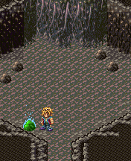

*Notice the stone reveals itself as something with magic, it indicates the change in the place. Also, the mysteriously the head of the monster disappears.*

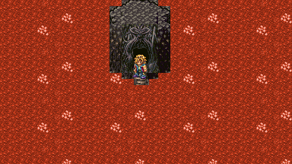

*When Rolan first enter's the mysterious place It's not anymore like what Mina saw.*

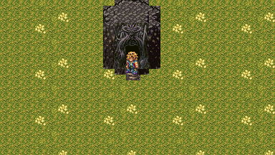

*After Rolan gave some few Items to the Giant Snake.*

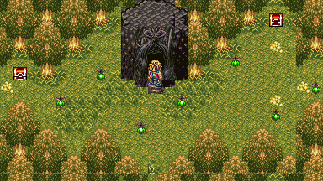

*After Rolan gave more unique items to the Giant Snake. The whole place has now returned to it's original form.*

#4.1 - Nightmare of the Monster

Friday, January 23, 2015

6:56 AM

**\*\*\*\*\*\*\*\*\*\*\*\*\*\*\*\*\*\***

**4.1.1 Overview**

**\*\*\*\*\*\*\*\*\*\*\*\*\*\*\*\*\*\***

After achieving the dreamworld of Jormurgand, you still have one last task to do to complete. You did not know that there's another dream of Jormurgand, and it is based from the items itself. There are 5 items that looks like equipments for a female. If you got these items and present it to Jormurgand, you will uncover a new dream. And that dream is a secret dream dungeon.

*This does not cover the level design yet and the environment design. But we have to plan out what will it be the plot of the dungeon.

**\*\*\*\*\*\*\*\*\*\*\*\*\*\*\*\*\*\***

**4.1.2 Key Ideas**

**\*\*\*\*\*\*\*\*\*\*\*\*\*\*\*\*\*\***

1. (Reward) Special Items
2. (Game) A Secret Dungeon
3. (Game) A Super Boss - The Strongest Boss in the Game. (The battle field changes depending in it's nature.)

**\*\*\*\*\*\*\*\*\*\*\*\*\*\*\*\*\*\***

**4.1.3 Music Idea**

**\*\*\*\*\*\*\*\*\*\*\*\*\*\*\*\*\*\***

**\*\*\*\*\*\*\*\*\*\*\*\*\*\*\*\*\*\***

**4.1.4 Visual Idea**

**\*\*\*\*\*\*\*\*\*\*\*\*\*\*\*\*\*\***

**\*\*\*\*\*\*\*\*\*\*\*\*\*\*\*\*\*\***

**4.1.5 Flow Chart**

**\*\*\*\*\*\*\*\*\*\*\*\*\*\*\*\*\*\***

This will only happened if you finished the first quest (The Monster's Dream Quest). And this one will take place later in the game.

***\*Exploration\****

Rolan, returned again to give something to the monster in the cave.

***\*Side Quest - Dream Dungeon\****

After the Dream of the Monster. We now know that you must give the monster items in order for the Dream Room to change. Now think about giving it a specific item. If you explore the entire world of the game, you will notice some items you get are not usual:

1. Goddess Headgear
2. Goddess Armor
3. Goddess Grieves
4. Ulimate Blade
5. Eternal Soul

*These items you get are things 'You cannot use' making you think that it serves no porpose, until you found that it can be given to the Snake, which makes some kind of *connection.*

If you manage to give the monster those, the monster will upgrade the Dream Room to a Dungeon.

This is a secret dungeon and not necessary for the completion of the game.

The boss here looks like the Divine Matron, but it's origin comes from the items you give created by the dream of the monster. Remember this is not a real deity, but a Copycat, if the Divine Matron is white, it's color probably Black and Red.

**Aftermath:**

Beating her grants you a powerful armor or amulet.

**\*\*\*\*\*\*\*\*\*\*\*\*\*\*\*\*\*\***

**4.1.6 Demo**

**\*\*\*\*\*\*\*\*\*\*\*\*\*\*\*\*\*\***

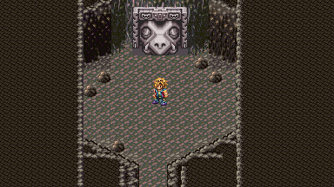

*You can do this after achieving the Monster's Dream Side Quest and after receiving 5 certain items.*

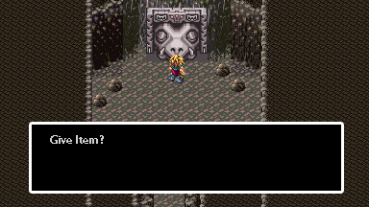

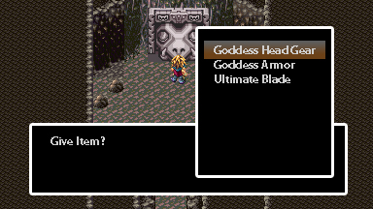

*After giving those 'mysterious' items, try to sleep now beside the rock.*

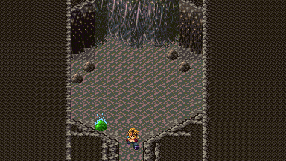

*If you exit when the rock is Green.*



*It will lead you to a secret area before.*

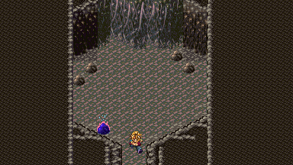

*If you exit when the rock is Blue...*

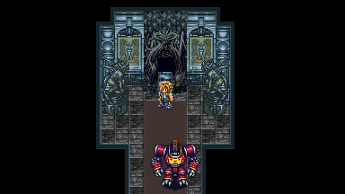

*It will lead you now to a secret dungeon*

*(The contents, mood, environment designs of the area must be weird and changing.)*

#5.1 - The Thief I

Tuesday, January 27, 2015

11:27 AM

**\*\*\*\*\*\*\*\*\*\*\*\*\*\*\*\*\*\***

**5.1.1 Overview**

**\*\*\*\*\*\*\*\*\*\*\*\*\*\*\*\*\*\***

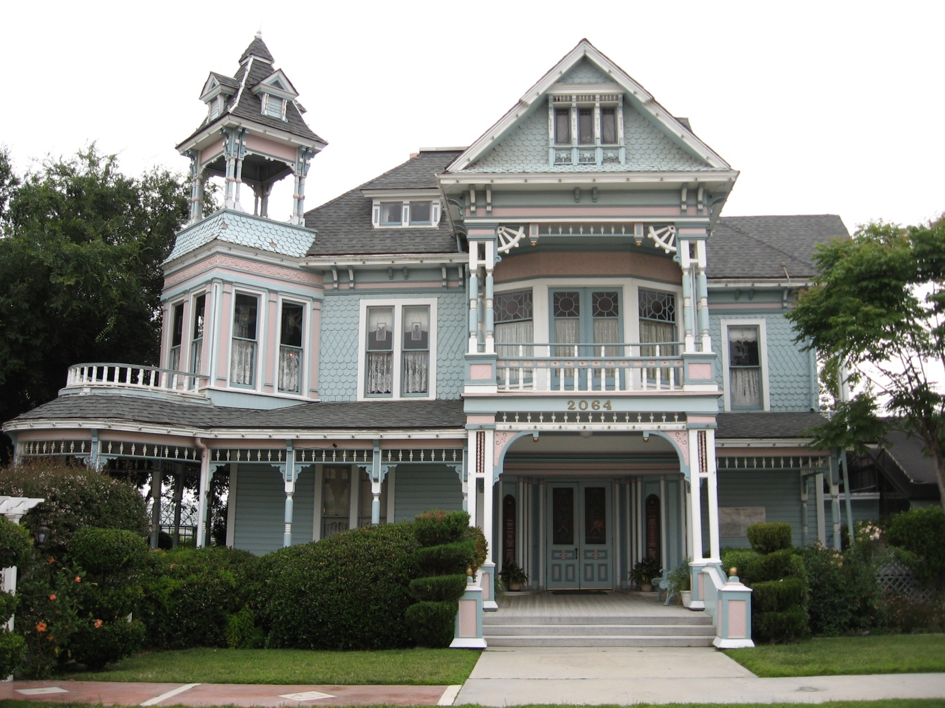

*"Beautiful place, well lit, all lights are on, and as you walk inside foods are prepared on the table for the guest. But problem, where are the guest? Not a single person is in here, except you."*

Concept: The idea is just walking 'alone'. The place is only a presentation of the Amulet's ability of Draining Enemy's life per hit and gives Rolan a regen buff.

That equipment item reflects the idea of the monster boss of the mansion that 'eats people' who tries to enter the place and regain health that reflects the healthy look of the mansion "magically". That is why, the mansion looks clean, every post or vandalism telling the mansion is dangerous will only disappear.

The location of the mansion is far from the town where the guild is. And people there have no knowledge about it, the only people who gain knowledge about it are the guild, but the people in the town mysteriously don't know anything about it.

The mansion looks beautiful and not scary, or haunted. The reason why is because the mansion wants people to enter it and proceed in it.

This is the reason why the guild hires someone who is a professional for stealing in order to go to that place. But you'll notice that they fear the place that is why they are hiring someone else.

**\*\*\*\*\*\*\*\*\*\*\*\*\*\*\*\*\*\***

**5.1.2 Key Ideas**

**\*\*\*\*\*\*\*\*\*\*\*\*\*\*\*\*\*\***

1. (Rewards) Rolan will rewarded a magical ring that Drains life when active. (Core)
2. (Game) A memory game. Player will be challenged his memory. (Core)
3. (Game) The Boss is slight strong than the Sword Tree Boss.
4. (Design Theme) A horror theme setting. (Core)

**\*\*\*\*\*\*\*\*\*\*\*\*\*\*\*\*\*\***

**5.1.3 Music idea**

**\*\*\*\*\*\*\*\*\*\*\*\*\*\*\*\*\*\***

1. Since it's a horror theme place, there 's no music at all but sound effects based in real life during night time.

**\*\*\*\*\*\*\*\*\*\*\*\*\*\*\*\*\*\***

**5.1.4 Visual Idea**

**\*\*\*\*\*\*\*\*\*\*\*\*\*\*\*\*\*\***

3.1.4.1 - Draft

The interior still looks new, and well lit with lamps at first. However, there is no sign of people here, even pests are none. But you'll see some prepared food on the table as if there should be some guests.

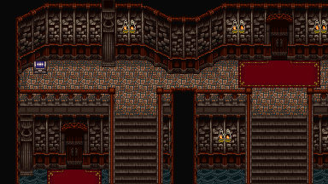

When the player progresses the place is starting to get spooky like the place is turning dark or the lights are turning off, the pictures is showing changes, also random sounds of laughing child or a woman. This will happened, when you are now at the end of the mansion.

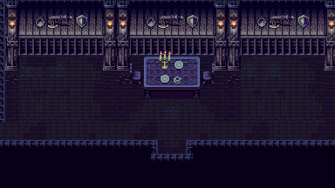

3.1.4.2 - Color Keys - From warm and lively to Dull and Dark

3.1.4.3 - Design: Mansion interior.

**\*\*\*\*\*\*\*\*\*\*\*\*\*\*\*\*\*\***

**5.1.5 Flowchart**

**\*\*\*\*\*\*\*\*\*\*\*\*\*\*\*\*\*\***

***Exploration:***

Rolan encounters a thief guild that is obsessed of obtaining a certain magical ring. Rolan just heard them talking, no inter communication happened. Some of them will spill a clue about where it is located. By getting those clues, it will trigger to open secret entrance somewhere in the in woods.

***Side Story:***

Rolan will hear about a thief who failed to steal a ring in a mansion. Knowing this will give a sense of that mansion you saw while travelling.

Somewhere at the entrance of mansion is an item called "Note", that note acts as a "key item" that triggers flashback whenever Rolan steps on a check point in the mansion.

All flashbacks are scenes of the thief in greyscale. Rolan must follow the path where the theif went. If Rolan fails, he will return back to the entrance and go thru from scratch again.

*It's a memory game*, and the horror theme adds the atmosphere of the place as part of the challenge.

If Rolan reached the last check point, he will witnes the thief in a room where he sees a note revealing the truth that the mansion is a magical hologram made by the ring. After reading, he was attacked by a monster and then the flashback black out.

Now that monster appears in front of Rolan and tries to attack. Rolan fights it.

After beating the monster. The mansion turned into an old broken place. And a ring gem appeared in front of Rolan to keep. That ring gem, can be something that can give Rolan Drain ability or something dark. The monster also will give a great amount of money.

If you went back to the theif guild, it will ask you something if you have the ring, saying it's a curse like "you must not have that ring because it’s a curse, surrender it to us so you will be safe." But actually you don't need to, if you think of it as valuable. If you sell it to them they will pay you same money you get from the monster. It's up to you if you sell it or not.

**\*\*\*\*\*\*\*\*\*\*\*\*\*\*\*\*\*\***

**5.1.6 Demo**

**\*\*\*\*\*\*\*\*\*\*\*\*\*\*\*\*\*\***

This is a horror themed memory game. So the design of the area must feel scary.

The memory game part, is like Follow the leader, you follow the Theif in the Flashback. And by accomplishing this serves the player to get to the next room or level.

Players are allowed to explore freely in the place. But they won't get progress to get the secret item if they didn't follow the quest.

1. Explore the place and search for the check point, it appears as a glowing graphic. (I'm allowing players to explore the place at least experience looking around.)
2. And then step on that check point and a flashback will occur.
3. That flashback shows the scene of the theif. At first you don't get it, probably no one can explain about the flashback. BUT what you will really going to do is to 'imitate' or 'copy' the theif in his actions. So when he moves and go to a certain place, you must do that also.
4. By doing that, it will make a ding-dong sound that indicates you passed the first stage.
5. Keep in mind, that the quest is active whenever the player steps on a check point. So if the player passed the first place, he can now be free to look over the next place to look for the next check point. However, the player is restricted of going back.

Demonstration:

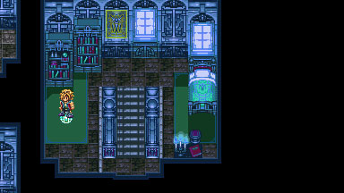

Rolan steps on the check point. If Rolan have the "Notes" from the Guild, it will trigger a flashback.

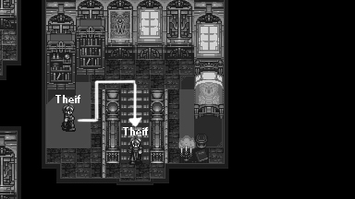

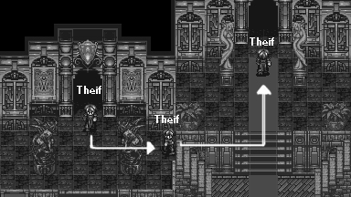

After the flashback, Rolan must follow where the theif goes.

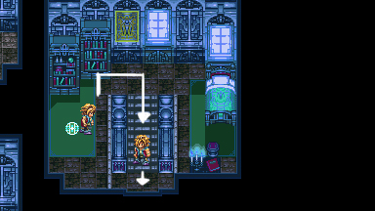

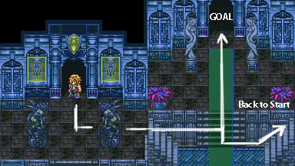

If Rolan went to the wrong way, he will return back at the entrance***.***

#6.1 - The Theif II

Saturday, February 14, 2015

4:48 PM

**\*\*\*\*\*\*\*\*\*\*\*\*\*\*\***

**6.1.1 Overview**

**\*\*\*\*\*\*\*\*\*\*\*\*\*\*\***

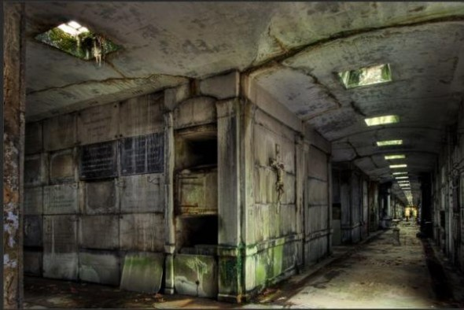

Similar how the the Theif story is executed, but the setting where the memory game takes place is in the underground setting. Player still follows what they will see in the flashback, however, in addition to the challenge is to follow what exactly the character is doing.

**\*\*\*\*\*\*\*\*\*\*\*\*\*\*\*\*\***

**6.1.2 Key Ideas**

**\*\*\*\*\*\*\*\*\*\*\*\*\*\*\*\*\***

1. (Rewards) Probably a Critical equipment or fragement that allows the player to have a greater chance of doing critical attacks.
2. (Game) A memory game.
3. (Game) Boss Battle
4. (Design Theme) A Underground Setting

**\*\*\*\*\*\*\*\*\*\*\*\*\*\*\*\*\***

**6.1.3 Music Idea**

**\*\*\*\*\*\*\*\*\*\*\*\*\*\*\*\*\***

**\*\*\*\*\*\*\*\*\*\*\*\*\*\*\*\*\*\***

**6.1.4 Visual Idea**

**\*\*\*\*\*\*\*\*\*\*\*\*\*\*\*\*\*\***



**\*\*\*\*\*\*\*\*\*\*\*\*\*\*\*\*\*\***

**6.1.5 Flowchart**

**\*\*\*\*\*\*\*\*\*\*\*\*\*\*\*\*\*\***

*Exploration*

If you explore the ruined castle or ruins. The place looks like been destroyed by a great power, you will see a stairs to the underground.

**\*\*\*\*\*\*\*\*\*\*\*\*\*\*\*\*\*\***

**6.1.6 Demo**

**\*\*\*\*\*\*\*\*\*\*\*\*\*\*\*\*\*\***

The game mechanics is similar to the Theif side story, the only difference is that it takes place inside the underground dungeon and the quest is more harder.

The flashback is shown whenever you take the check point, and what you are going to do is to follow the theif.

Now the dungeon is not a ghost or magic made, it is real. It will still make you return to the entrance if you fail.

Flashbacks includes, the theif is reading a message, the theif is finding a clue, and the theif is opening a door using a password. Unlike the first of this side quest, you are also going to use words as part of the quest. This quest requires not only memory but analysis. But in the end the price is hopefuly must be good.

#7.1 - The Bridge

Monday, February 02, 2015

2:36 PM

**\*\*\*\*\*\*\*\*\*\*\*\*\*\*\***

**7.1.1 Overview**

**\*\*\*\*\*\*\*\*\*\*\*\*\*\*\***

A very simple story with a gameplay of escorting. 2 siblings wants their parents to be proud of them. They are treated worthless and stupid who don't know how to farm. So they want to show their worth by deliving the things to sell to the city. But the problem is the route they are going, there a many monsters. Will Rolan escort them?

**\*\*\*\*\*\*\*\*\*\*\*\*\*\*\*\*\***

**7.1.2 Key Ideas**

**\*\*\*\*\*\*\*\*\*\*\*\*\*\*\*\*\***

1. (Rewards) Boost equipments and a Lucky Charm
2. (Game) Escort mission
3. (Game) There are 4 stages and each stages are leveled from easy to hard and it's because of the level design of each stage. And one final stage that compose of 3 mini games based from the first 3 stages, except new prices.
4. (Setting) The place outside is a field, and somewhere is a cliff that is a safe path, that makes you think that if you build a bridge there it will make easy for the people to travel the place safely.

**\*\*\*\*\*\*\*\*\*\*\*\*\*\*\*\*\***

**7.1.3 Music Idea**

**\*\*\*\*\*\*\*\*\*\*\*\*\*\*\*\*\***

**\*\*\*\*\*\*\*\*\*\*\*\*\*\*\*\*\*\***

**7.1.4 Visual Idea**

**\*\*\*\*\*\*\*\*\*\*\*\*\*\*\*\*\*\***

**\*\*\*\*\*\*\*\*\*\*\*\*\*\*\*\*\*\***

**7.1.5 Flowchart**

**\*\*\*\*\*\*\*\*\*\*\*\*\*\*\*\*\*\***

2 Youngsters are wants their father and mother to be proud of them, but they are treated as worthless and stupid who don't know how to farm. So they want to show their worth by deliving the things to sell in the city. But the problem is the route they are going, there a many monsters. Rolan can escort them

The first stage - You have to escort the children riding a car with the package, you have to protect them from the monsters: After finishing the the escort mission a cutscene will be shown, the 2 are happy expects that their parents will be pleased, but instead they are treated badly, their father kick them out and didn't gave any food. If Rolan talks to them, they will say that they have a plan.

The second stage - You have to escort the children again going in a different route and city: After finishing, there will another cutscene that shows that their parents are talking about putting their children to orphanage. The 2 youngsters are in struggle to not make that happened, so they ask a chance from them. This will reveal, another mission for Rolan.

The third stage - You have to escort the children again going to another route: After finishing this, you will see another cutscene that shows their parents talking to a person that looks like someone will take over them. They reveal that they are not their true parents and they are sold to that man, and the man is someone that don't take the children to the right place but to slavery. Rolan must save them.

The forth stage - You have to escort them while protecting them from the man and his dogs. Unlike the first mission, the monsters here are agressing and following you. If you happened to finish this stage, you will put the children to trusted person npc that takes children and free school. After this, you thought it's already finished, now take the fifth stage.

The fifth stage - After finishing some quests, a crazy escort mission for the last time, you will see a puppy in the town that if you get near of it it will will go outside. If you follow it, you will have to protect it travelling to the next town, specifically to the daycare, if you fail, it will return back to the town. If you successfully made it, the puppy will be taken by the daycare saying it as their lost puppy. You will be informed that the children are Gone, the manager are happy about them.

Now you will see a bridge to other side is now being built, and passing it allows you to instantly go to other side place (This just a setting shortcut maker). And you will see the children in the gate, guarding it and managing it. They said that they obtain something hidden, that made them rich and build a bridge. But they just give it up to Rolan as a sign of gratitude. A Lucky Charm (Boost luck greatly or chance of doing critical. This ends up the their story but opens a mini game of escorting people, handled by that children. Rolan can do mini game of escorting people in 3 areas like before. If you manage to get the best score you can win an Exp boost amulet or Str Boost or Stats boost equipments.

**\*\*\*\*\*\*\*\*\*\*\*\*\*\*\*\*\*\***

**7.1.6 Demo**

**\*\*\*\*\*\*\*\*\*\*\*\*\*\*\*\*\*\***

#8.1 - That Girl's Arena

Monday, February 02, 2015

2:36 PM

**\*\*\*\*\*\*\*\*\*\*\*\*\*\*\***

**8.1.1 Overview**

**\*\*\*\*\*\*\*\*\*\*\*\*\*\*\***

A girl opens up a battle ground searching for the strongest warrior. In the end, the girl will reveal herself as the contender, she is 'known' but not saying as the strongest fighter in the game.

After beating a certain amount of unique monsters in the game. You will gain recognition and a group of mysterious people is going to capture you and put you to a new setting where a unknown arena is placed. A female contractor will tell you about the place that will lead you to a set of monsters to battle. If you manage to beat all of them, you will be freed. The Girl will give Rolan her contact, telling Rolan can visit anytime if he is interested to battle more monsters.

If you manage to beat all monsters, the girl will surprice you to battle her. She will give the reason why she made the area is to discover her true "partner".

The Girl is not a villian, she's just childish and her reason is crazy.

**\*\*\*\*\*\*\*\*\*\*\*\*\*\*\*\*\***

**8.1.2 Key Ideas**

**\*\*\*\*\*\*\*\*\*\*\*\*\*\*\*\*\***

1. (Game) Arena.
2. (Game) Super Boss: Less stronger to the Monster's Dream Boss.

**\*\*\*\*\*\*\*\*\*\*\*\*\*\*\*\*\***

**8.1.3 Music Idea**

**\*\*\*\*\*\*\*\*\*\*\*\*\*\*\*\*\***

**\*\*\*\*\*\*\*\*\*\*\*\*\*\*\*\*\*\***

**8.1.4 Visual Idea**

**\*\*\*\*\*\*\*\*\*\*\*\*\*\*\*\*\*\***

**\*\*\*\*\*\*\*\*\*\*\*\*\*\*\*\*\*\***

**8.1.5 Flowchart**

**\*\*\*\*\*\*\*\*\*\*\*\*\*\*\*\*\*\***

After beating a certain amount of unique monsters in the game. You will gain recognition and a group of mysterious people is going to capture you and put you to a new setting where a unknown arena is placed. A girl will introduce herself and leads you to fight strong unique monsters in the Game, usually, the father of it's kind. After finishing 7 monsters straight you will be rewarded and gain freedom (End of story).

In continuation, this will open a mini game arena, you can return back to this new place on the map. You will be given access to fight a new set of monsters.

If you manage to beat the arena, the Girl will fight you, saying that the reason why she made the arena is too look for someone who is strong to handle her.

If you beat her, the Girl will give Rolan a special item or equipment. (She will say that she is looking for a "Real man")

**\*\*\*\*\*\*\*\*\*\*\*\*\*\*\*\*\*\***

**8.1.6 demo**

**\*\*\*\*\*\*\*\*\*\*\*\*\*\*\*\*\*\***

#9.1 - Caroline's Grey Castle

Friday, January 23, 2015

11:17 AM

**\*\*\*\*\*\*\*\*\*\*\*\*\*\*\***

**9.1.1 Overview**

**\*\*\*\*\*\*\*\*\*\*\*\*\*\*\***

She is a cute/sexy girl with a large hammer weapon, she is one of the Secret Boss in the story. She is a user of a strange art of Blacksmith. She can break the nature making the elements change to another element using her Hammer Skill. And every of her magic attacks are in full power meaning you can easily die with just one hit. Honey has an ability to capture molecules, and that he can use it as a source to blast super strong magic. Additionally, if she uses her Hammer Skill, it will trick you that what you are getting is not the element you expect. Like if she blast you fire, instead of elemental flame, you will receive a water element. However, it's primary weakness is she is predictable and slow.

When Rolan met her, she will give some tasks to do, and those tasks eventually will reveal her story. This part will be the game.

But in the end, Rolan will fight her, for reason of getting a strong piece of item. Rolan will not kill her but defeat her arts she proud of.

Backstory:

Her story tells about her passion of her hobby, Improving her Hammer Skills. She left her family as she don't want to be controlled and forced to do something she don't like, like fixing her marriage and career. Her father don't like her hobby, he think its only a waste of time. Because of that, She leaves and move on to follow her dreams. In the end, she became a powerful being after discovering the great knowledge. She gain her own place a Grey Castle, where she lives as a Queen.

**\*\*\*\*\*\*\*\*\*\*\*\*\*\*\*\*\***

**9.1.2 Key Ideas**

**\*\*\*\*\*\*\*\*\*\*\*\*\*\*\*\*\***

1. (Game) Super Boss - The Boss battle style may put you to challenge more that the strongest boss. This because what you are going to do is to make the Boss set of skills be "not effective" to you.

**\*\*\*\*\*\*\*\*\*\*\*\*\*\*\*\*\***

**9.1.3 Music Idea**

**\*\*\*\*\*\*\*\*\*\*\*\*\*\*\*\*\***

**\*\*\*\*\*\*\*\*\*\*\*\*\*\*\*\*\*\***

**9.1.4 Visual Idea**

**\*\*\*\*\*\*\*\*\*\*\*\*\*\*\*\*\*\***

**\*\*\*\*\*\*\*\*\*\*\*\*\*\*\*\*\*\***

**5.1.5 Flowchart**

**\*\*\*\*\*\*\*\*\*\*\*\*\*\*\*\*\*\***

When Rolan talks to her, he will be given a task to do, like check this area and get this item, go to this area and kill this monster, do this and do that. Everytime you succeed, you will get something about her.

The point of this is to let the player see more areas in the game.

At the end, she will gain items that she really want, and now she will let you go. However, if you want to take the items she have, you will have an option to fight her. This challenge will give you a rare item as a reward. This fight is not you're going to kill the Girl but destroying only her Skills. Meaning to say you're not going to kill her but make her skills ineffective to you.

Example: When she used her 2nd skill, IF you successfully counter it, it will make her stop using it. If you made her stop using 4 of her skills, it will maker her use her bests skill set. Countering one of those will stop her using it.

The challenge requires you to think and have better reflex. Because the skills are hard to counter.

This boss should be difficult.

**\*\*\*\*\*\*\*\*\*\*\*\*\*\*\*\*\*\***

**5.1 .6 Demo**

**\*\*\*\*\*\*\*\*\*\*\*\*\*\*\*\*\*\***